ANTI-BULLYING PLAN
Bowning Public School 2024

At Bowning Public School we believe that our students should be nurtured to become engaged and successful learners and every students has the right be feel safe at school. At BPS we want to create positive relationships with and among our students and with our staff, however, we understand that there may be students who at times, may be victims and/or perpetrators of bullying. We believe that all school stakeholders, particularly staff, students and parents, need to be aware of strategies to identify and respond to incidents of bullying.
Bullying behaviour has three key features. It involves the intentional misuse of power in a relationship. It is ongoing and repeated, and it involves behaviours that can cause harm. The NSW Department of Education requires all NSW public schools to have an Anti-bullying Plan which details the strategies implemented to reduce student bullying behaviours.

Resources
The NSW anti-bullying website (see: https://antibullying.nsw.gov.au/) provides evidence-based resources and information for schools, parents and carers, and students. Schools are encouraged to visit the website to support whole-school prevention, early intervention and response approaches and strategies for student bullying behaviour.
Bowning Public School's commitment
Our school rejects all forms of bullying behaviours, including online (or cyber) bullying by maintaining a commitment to providing a safe, inclusive and respectful learning community that promotes student wellbeing. All staff are committed to establishing evidence-based approaches and strategies that promote a positive climate where bullying is less likely to occur.
School culture and inclusion
All members of the school community are active participants in building a welcoming school culture that values diversity and fosters positive relationships. A key component of a supportive school culture is building respectful relationships and an ethos that bullying is not accepted, in both online and offline environments. School staff will actively respond to student bullying behaviour.
Our school engages in the following practices to promote a positive school culture.
Whole School Language
Student bullying and expectations about student behaviour will be discussed and information presented to promote a positive school culture where bullying is not accepted. We wish to empower victims and disempower bullies. We wish to educate all students about bullying. We endeavour to create a culture in which students feel able to talk about bullying, knowing that their concerns will be heard and that we will take action to ensure that all students feel safe at school and, therefore, are happy to come to school

Dates | Communication topics
First week | Openly talk about bullying – what it is, how it affects us and what we can do about it.  Behaviour code discussed with all students in class
Each week | Teach our children the skills which will build their self-esteem and empower them to take responsibility for themselves – and give them the opportunity to practise these skills  All students will engage in a social skills lesson through PD/H/PE and emotional literacy, explicitly teaching of social and emotional skills.
Throughout the year | - Bullying No Way Day – All students will engage in a whole school focus on anti-bullying language. 16th August  - Fairy Bread Day – All students will engage in a whole school focus on kindness. 24th November
Each day | To model appropriate behaviours at all times  Rewards for antibullying, model and promote positive relationships that respect and accept individual differences and diversity within the school community  Follow school
Staff Communication and professional learning
Staff will be supported with professional learning that provides evidence-based ways to encourage and teach positive social and emotional wellbeing and discourage, prevent, identify, and respond effectively to student bullying behaviour.
At Bowning Public new and casual staff will be informed of the school's approach and strategies to prevent and response to student bullying behaviour. New and casual staff will be given a school handbook that outlines processes on school bullying. Staff will be asked to read this on their first day at Bowning Public School and ask any questions they have around the school's approach and process to student bullying behavior.
Visual displays in the playground will support staff to have a clear understanding of processes for antibullying.

Dates | Communication topics
Each term | - Staff Development Day - Wellbeing  - Achieving school Excellence in Wellbeing and Inclusion delivered to staff
Ongoing development | - Attendance Matters  - Trauma informed practice  - Berry Street Model  - Zones of Regulation  - Restorative practice
Twice a term | - Learning Support meetings are held to discuss student wellbeing concerns and strategies.
Each year review process | To deal with all reported and observed incidences of bullying as set out in our responsible thinking procedures  Responding the bullying  - Staff are informed verbally, email, student portal.  - Staff reports alleged bullying to Principal  - Witness statements at earliest instance  - Ongoing monitoring by staff or further investigation of matter by Principal  - Appropriate response including parent contact and recording  - Bully and Victim to be referred to School counsellor if required  Please note that if at any stage there is a child protection concern, the NSW Mandatory Reporting Guide will be used by the member of staff who received the initial report to determine whether a report to the Principal and the Child Protection Helpline is required.
Partnership with families and community
Effective schools have high levels of parental and community involvement. This involvement is strongly related to improved student learning, attendance and behaviour. Our school proactively builds collaborative relationships with families and communities to create a shared understanding of how to support student learning, safety and wellbeing.

Dates | Communication topics
First week | Community charter
Termly | Zones of Regulation  Berry Street Model  Bullying No Way
Each day | To become aware of and supportive of our behaviour management and bullying policy  Communication in newsletter  To reinforce appropriate behaviours with their children
Our school website has information to support families help their children to regulate their emotions and behaviour and develop socially. Information is provided to assist if children have been involved in bullying behaviour (as the person engaging in bullying behaviour, as the person being bullied or as the person witnessing the bullying behaviour).
The following are published on our school’s website. Check the boxes that apply.

✔ School Anti-bullying Plan ✔ NSW Anti-bullying website | ✔Behaviour Code for Students

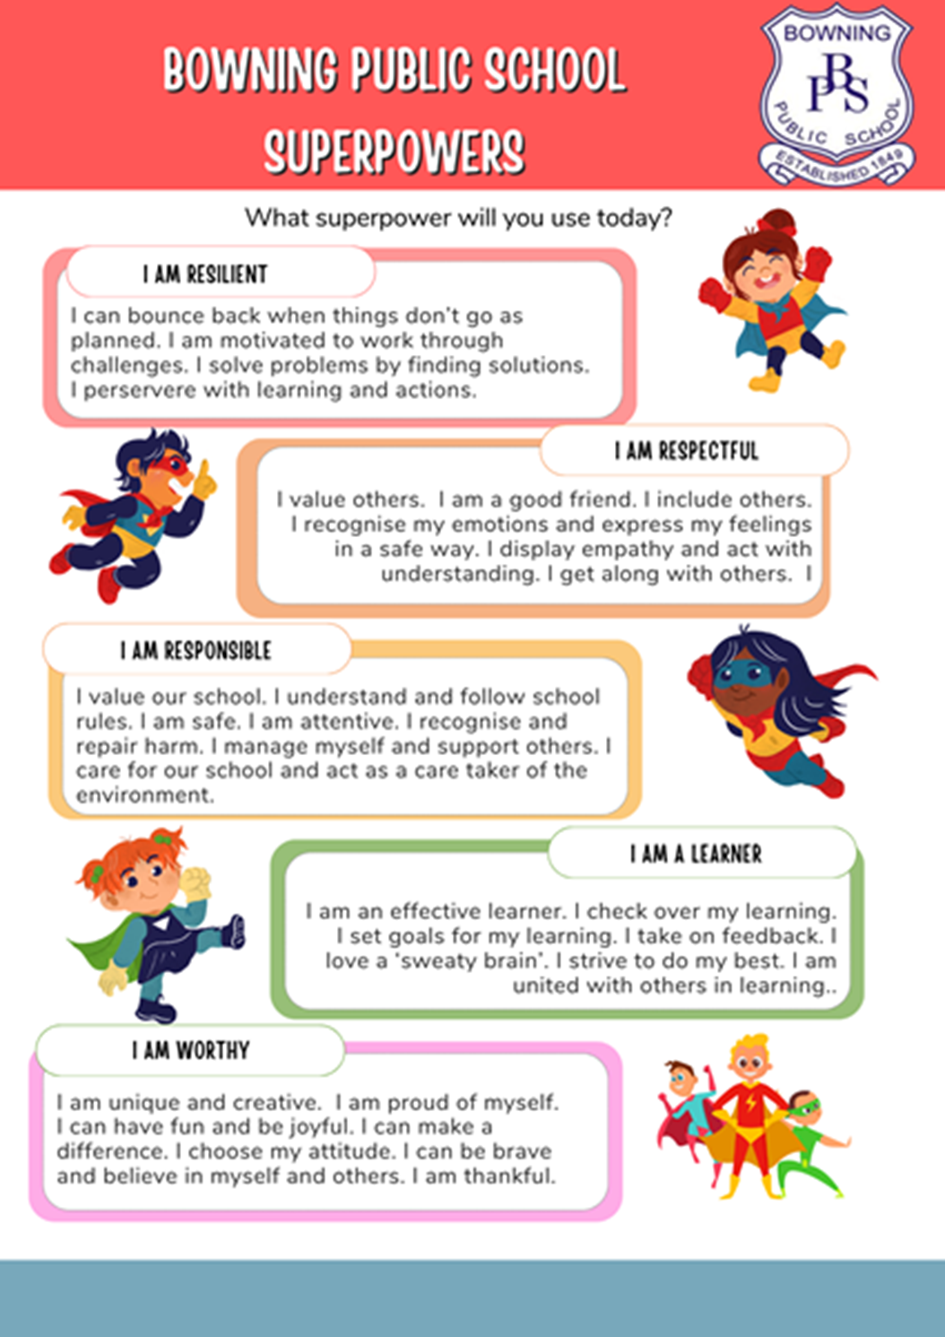

Communication with parents
Our school will provide information to parents to help promote a positive school culture where bullying is not acceptable and to increase parent’s understanding of how our school addresses all forms of bullying behaviour.

Dates | Communication methods and topic
2024 | Parent meeting i.e P&C, parent/teacher night - Defining student bullying and school supports
2024 | School Newsletter
2024 | Code of Conduct at sporting events
2024 | School Website/School Facebook
Resources to share | Anti-Bullying – Parents and Carers Tips  Bullying No Way  Kids Help Line  counsellor@kidshelpline.com.au – an email for parents to contact around bullying.

Support for wellbeing and positive behaviours
Our school’s practices support student wellbeing and positive behaviour approaches that align with our school community’s needs. Social and emotional skills related to personal safety, resilience, help-seeking and protective behaviours are explicitly taught across the curriculum in Personal Development, Health and Physical Education (PDHPE). Examples of other ways our school will embed student wellbeing and positive behaviour approaches and strategies in practices include the following.
School Learner Profiles and reward systems
Weekly Bounce Back lessons.
Daily practices from Berry Street Model including Welcome circle and Check ins.
Breakfast Club - a program that supports all students who are provided with breakfast. Making sure students have eaten before school ensures students wellbeing and positive behaviour is managed effectively.

Completed by: Belinda Brown, Christine Worland, Tracy Ranie, Sally Howlett, Julie Jenkins. Maddison Douvan, Belinda McRae, Barry OMara
Position: Teachers
Date:
April 2024
Principal name: Belinda Brown
Date:
April 2024

